**Load**

* Aumkar: HTML/SQL/PHP
* Marcel: HTML/Javascript/SQL/PHP
* Sandy: museum pages, technical report

**Design/Layout of UIs**

The following diagrams show how the webpages were structured. All of the webpages for artworks, artists, museums, the shopping cart, and the modify page were connected to the index page using JavaScript.

The window.open() method was used to open the webpages as popups. The window.location.assign() method was used to change the main page to show the artwork, artist, or museum.

Figure : Home Page. Note: doesn’t include the shopping cart section due to size constraints.

Figure : Art Work Pages

Figure 3: Artist Pages

Figure 4: Museum Pages

The diagram below shows the shopping cart page featured on all of the pages. This feature can be accessed by clicking the shopping cart button.

The shopping cart allows the user to purchase an artwork item by first selecting the artwork using the drop down list created by the <select> tag. The quantity of artwork purchased can be entered in the textbox created using the <input> tag. The user can then select the type of shipping using the radio buttons created by the <button> tags. Clicking the subtotal button will allow the user to see the subtotal. The user can reset their choices by clicking the reset button or submit their order using the submit button.

The subtotal is calculated using the JavaScript function total(). This function calculates the subtotal by multiplying the values from the radio button for the shipping plan and the artwork price.

Figure 5: Shopping Cart featured on Artwork pages

The diagram below shows the maintain page. It is used to add a piece of art to the database. Using the <form> tag, the maintain page takes the information input by the user and adds it to the database.

The user enters the title of the artwork, artist, creation date, location, colour type, dimensions, and price of the artwork that they want to add. The user then selects a genre from the drop down list created by the <select> tag. After clicking the submit button, the artwork is added to the database. The results are shown on “addartwork.php”.

Figure 5: Maintain Page

**Design/Structure of Database**

The tables were set up such that there was a table for each of the following categories: artworks, artists, genres and museums. Other tables, such as customers, were set up to store the customer information. The Images table contains the images of the artworks, artists, and museums.

The relationships between the tables are shown through their primary and foreign keys in the table below.

|  |  |  |
| --- | --- | --- |
| Table Name | Primary Key | Foreign Key |
| artist | artist_id |  |
| artworks | art_id | artist_id, genre_id |
| customers | order_id | genre_id |
| genre | genre_id |  |
| images | image_id | art_id |
| museum | mus_id | art_id |

The diagram below shows the database ER relationship diagram of the database. Primary keys are in bold. The names of the tables are the headers of each box. The foreign keys have icons containing an arrow. The relationship between the tables are shown using arrows.

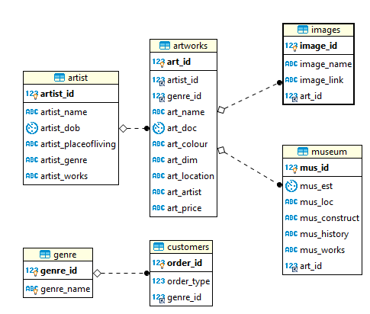

The following screenshots show how the tables are accessed within the database. They contain the values in each table.

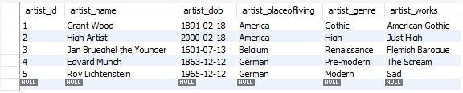

Figure 1: Artist table

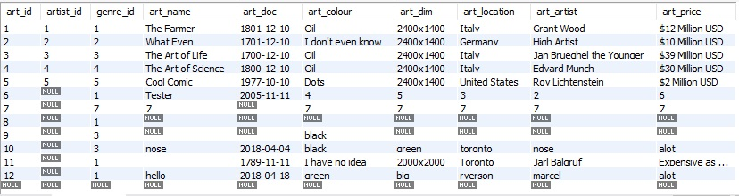

Figure 1: Artworks table

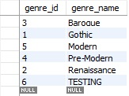

Figure 1: Genre table

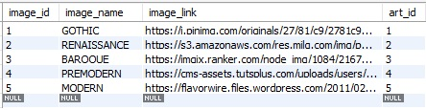

Figure 1: Image table

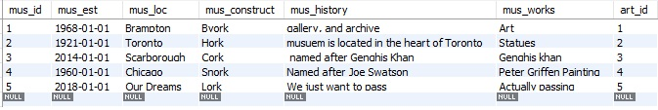

Figure 1: Museum table

**Design/Implementation of Database Maintain Mode**

Artworks can be maintained within the database using the following commands.

Add: to add a piece of artwork, use the following command.  
 INSERT INTO artworks (art_id, artist_id, genre_id, art_name, art_dim, art_location, art_doc, art_colour, art_price)  
 VALUES (*artwork id, artist name, genre type, artwork name, dimensions, location, creation date, colour, price*)

Delete: to delete a piece of artwork, use the following command (Safe modify on Mysql workbench should be turned off first).  
 ALTER TABLE artworks  
 DROP COLUMN (art_id)

Modify: to modify a piece of artwork, use the following command(Safe modify on Mysql workbench should be turned off first).  
 ALTER TABLE artworks  
 ALTER COLUMN art_id=2

Search:

SELECT * FROM artwork WHERE art_name LIKE $search

*Where $search is any value you want to search for*